# **Introduction**

Estuaries around the world are under cumulative stress from a variety of natural and anthropogenic disturbances, which may occur over short or sustained periods of time. Sources of these stressors may occur on a variety of spatial and temporal scales, from extensive conversion of estuarine floodplain for municipal and industrial use (Finn et al., 2021), to local disturbances such as scouring events during storms or tidal surges (Pasternack, 2009).These cumulative impacts can have negative consequences on plant communities comprising estuarine habitat, such as native species biodiversity loss or species homogenization, leading to altered community structure and functional processes (Price et al., 2020; Simberloff et al., 2013). Not only does this directly impact the biodiversity and function of an estuary, but it can erode resistance to subsequent disturbance through ecological “memory loss” as historically abundant species become locally extirpated (Diefenderfer et al., 2021), which may lead to alternative successional trajectories (Johnstone et al., 2016; Schaefer, 2011).

Ecological memory is maintained through propagule availability, which may be present in the form of seeds deposited into the sediment surface (“surface seed bank”), or vegetative clonal fragments retained at or dispersed into the site.

Propagules present or arriving post-disturbance are then dependent upon “windows of opportunity” to establish (Balke et al., 2014), during which propagules are either tolerant to subsequent disturbance events, or disturbance is absent in the establishment window. This is particularly key in highly dynamic estuaries such as tidally-influenced wetlands where, for example, recurring inundation favors successful establishment by clonal fragments over seed-based establishment (Silinski et al., 2016). Increases in the frequency or duration of disturbances locally can impact the available recruitment window for historically successful propagules (ref). This can become a compounding feedback loop between reduced propagule availability and increased propagule failure. Example not directly related to grazing?

Some natural disturbance events, like grazing, may occur as either discrete, short-term events, or as long-term disturbance agents in an ecosystem. In many estuaries historically, grazing would have been minimal and quickly removed, *e.g…*… In these conditions, plant communities were able to passively recover through natural recruitment and succession (Meli et al., 2017). However, intensive or persistent grazing is becoming more common with the introduction of novel grazers (ref), and the loss of productive grazing areas due to landscape change (ref). These new grazing pressures can effectively reset successional processes through total removal of propagative materials, and potentially set the plant community on a recovery trajectory towards an alternative stable state via novel propagules introduced into the disturbed site (Abernethy & Willby, 1999; Srivastava & Jefferies, 1996). Through alternative competitive strategies, these novel species can shift recovery trajectories to a new compositional palette.

Estuaries around the Salish Sea in the Pacific Northwest of North America are dominated by swards of graminoids (sedges, rushes, grasses) whose competitive strategies include clonal vegetative reproduction and tall (> 1 m) canopy cover, interspersed with a diversity of broadleaf, flowering species (“forbs”) (Borde et al., 2020). Many estuaries in this region are overgrazed by non-native, hyperabundant Canada geese (*Branta canadensis*) (Dawe et al., 2011; Dawe & Stewart, 2010). In addition to removing leafy above-ground vegetation, Canada geese will rip out or “grub” starchy rhizomes capable of clonal reproduction, which in turn increases potential for ecological memory loss in the form of eroding marsh sediments and their seed banks. Estuary plant communities impacted by intensive goose herbivory must either recover from clonal expansion from adjacent remnant patches, or through seed recruitment from seed dispersed and retained on the eroded site. In landscapes experiencing both environmental shifts and dramatic changes in propagule pressure, however, whether plant communities passively recover towards a compositional abundance comparable to ungrazed plant communities may be increasingly independent of the presence of intact, clonally dominated communities adjacent to the grazed areas.

Our main objective of this study was to understand propagule availability within surface seed banks and above-ground vegetation recovery at discrete stages since grazing removal in two Salish Sea estuaries. Traditional succession models would say the most competitive species will increasingly dominate the plant community as time since disturbance increases (Tilman, 1990). This would particularly be the case in a clonal ecosystem, where recovery is driven by species spreading clonally from adjacent undisturbed sites, in addition to potential recruitment from the seed bank. If succession is happening the way we expect:

1. Compositional abundance of dominant tall, perennial graminoids in above ground vegetation at older disturbance sites will have greater similarity to undisturbed (reference) vegetation than recently disturbed sites.
   1. Alternatively, the novel disturbance and altered propagule availability can lead to alternative succession pathways, where new species can achieve competitive dominance through seed or clonal recruitment, derailing the slow clonal encroachment of historically dominant species from neighboring sites. If this is the case, we expect compositional abundance of competitively dominant species in the older disturbance sites will be significantly different from that of undisturbed sites.
2. Because a longer post-grazing recovery period should lead to above-ground competitive dominance by key species as well as facilitate greater seed bank richness, we expect compositional abundance of surface seed banks should closely resemble that of above-ground vegetation in recently disturbed sites and become more species-rich and dissimilar from above-ground vegetation with time since disturbance.

# **Methods**

## **Study area & site history**

The Little Qualicum River Estuary (LQRE) and Nanaimo River Estuary (NRE) are situated on the east coast of Vancouver Island along the Strait of Georgia (Figure 1) and are on the ancestral, unceded territories of Coast Salish Peoples, including the K’ómoks, Snuneymuxw, Qualicum Band, and Nanoose First Nations. Prior to European colonial settlement, traditional practices by First Nations around the Salish Sea would have included managing estuaries as root gardens to promote the abundance of broadleaf flowering species with starchy roots, rather than the perennial graminoids that competitively dominate the estuaries today (Turner et al., 2013). Colonial settlement of the LQRE began in 1887, with cattle grazing, log booming, and sawmill operations being the chief uses of the estuary until 1974 when 29 ha of the estuary were donated to the Canadian Wildlife Service for conservation purposes, and subsequently designated as a provincially protected Wildlife Management Area (WMA) in 1993 (Clermont, 2010). The NRE was similarly settled through the late 19th and 20th centuries, and heavily augmented through construction of a ferry terminal, logging operations, and coal mining. While the NRE is part of the UNESCO-designated Mount Arrowsmith Biosphere Region and portions fall under conservation management, it is not provincially protected through designation as a WMA.

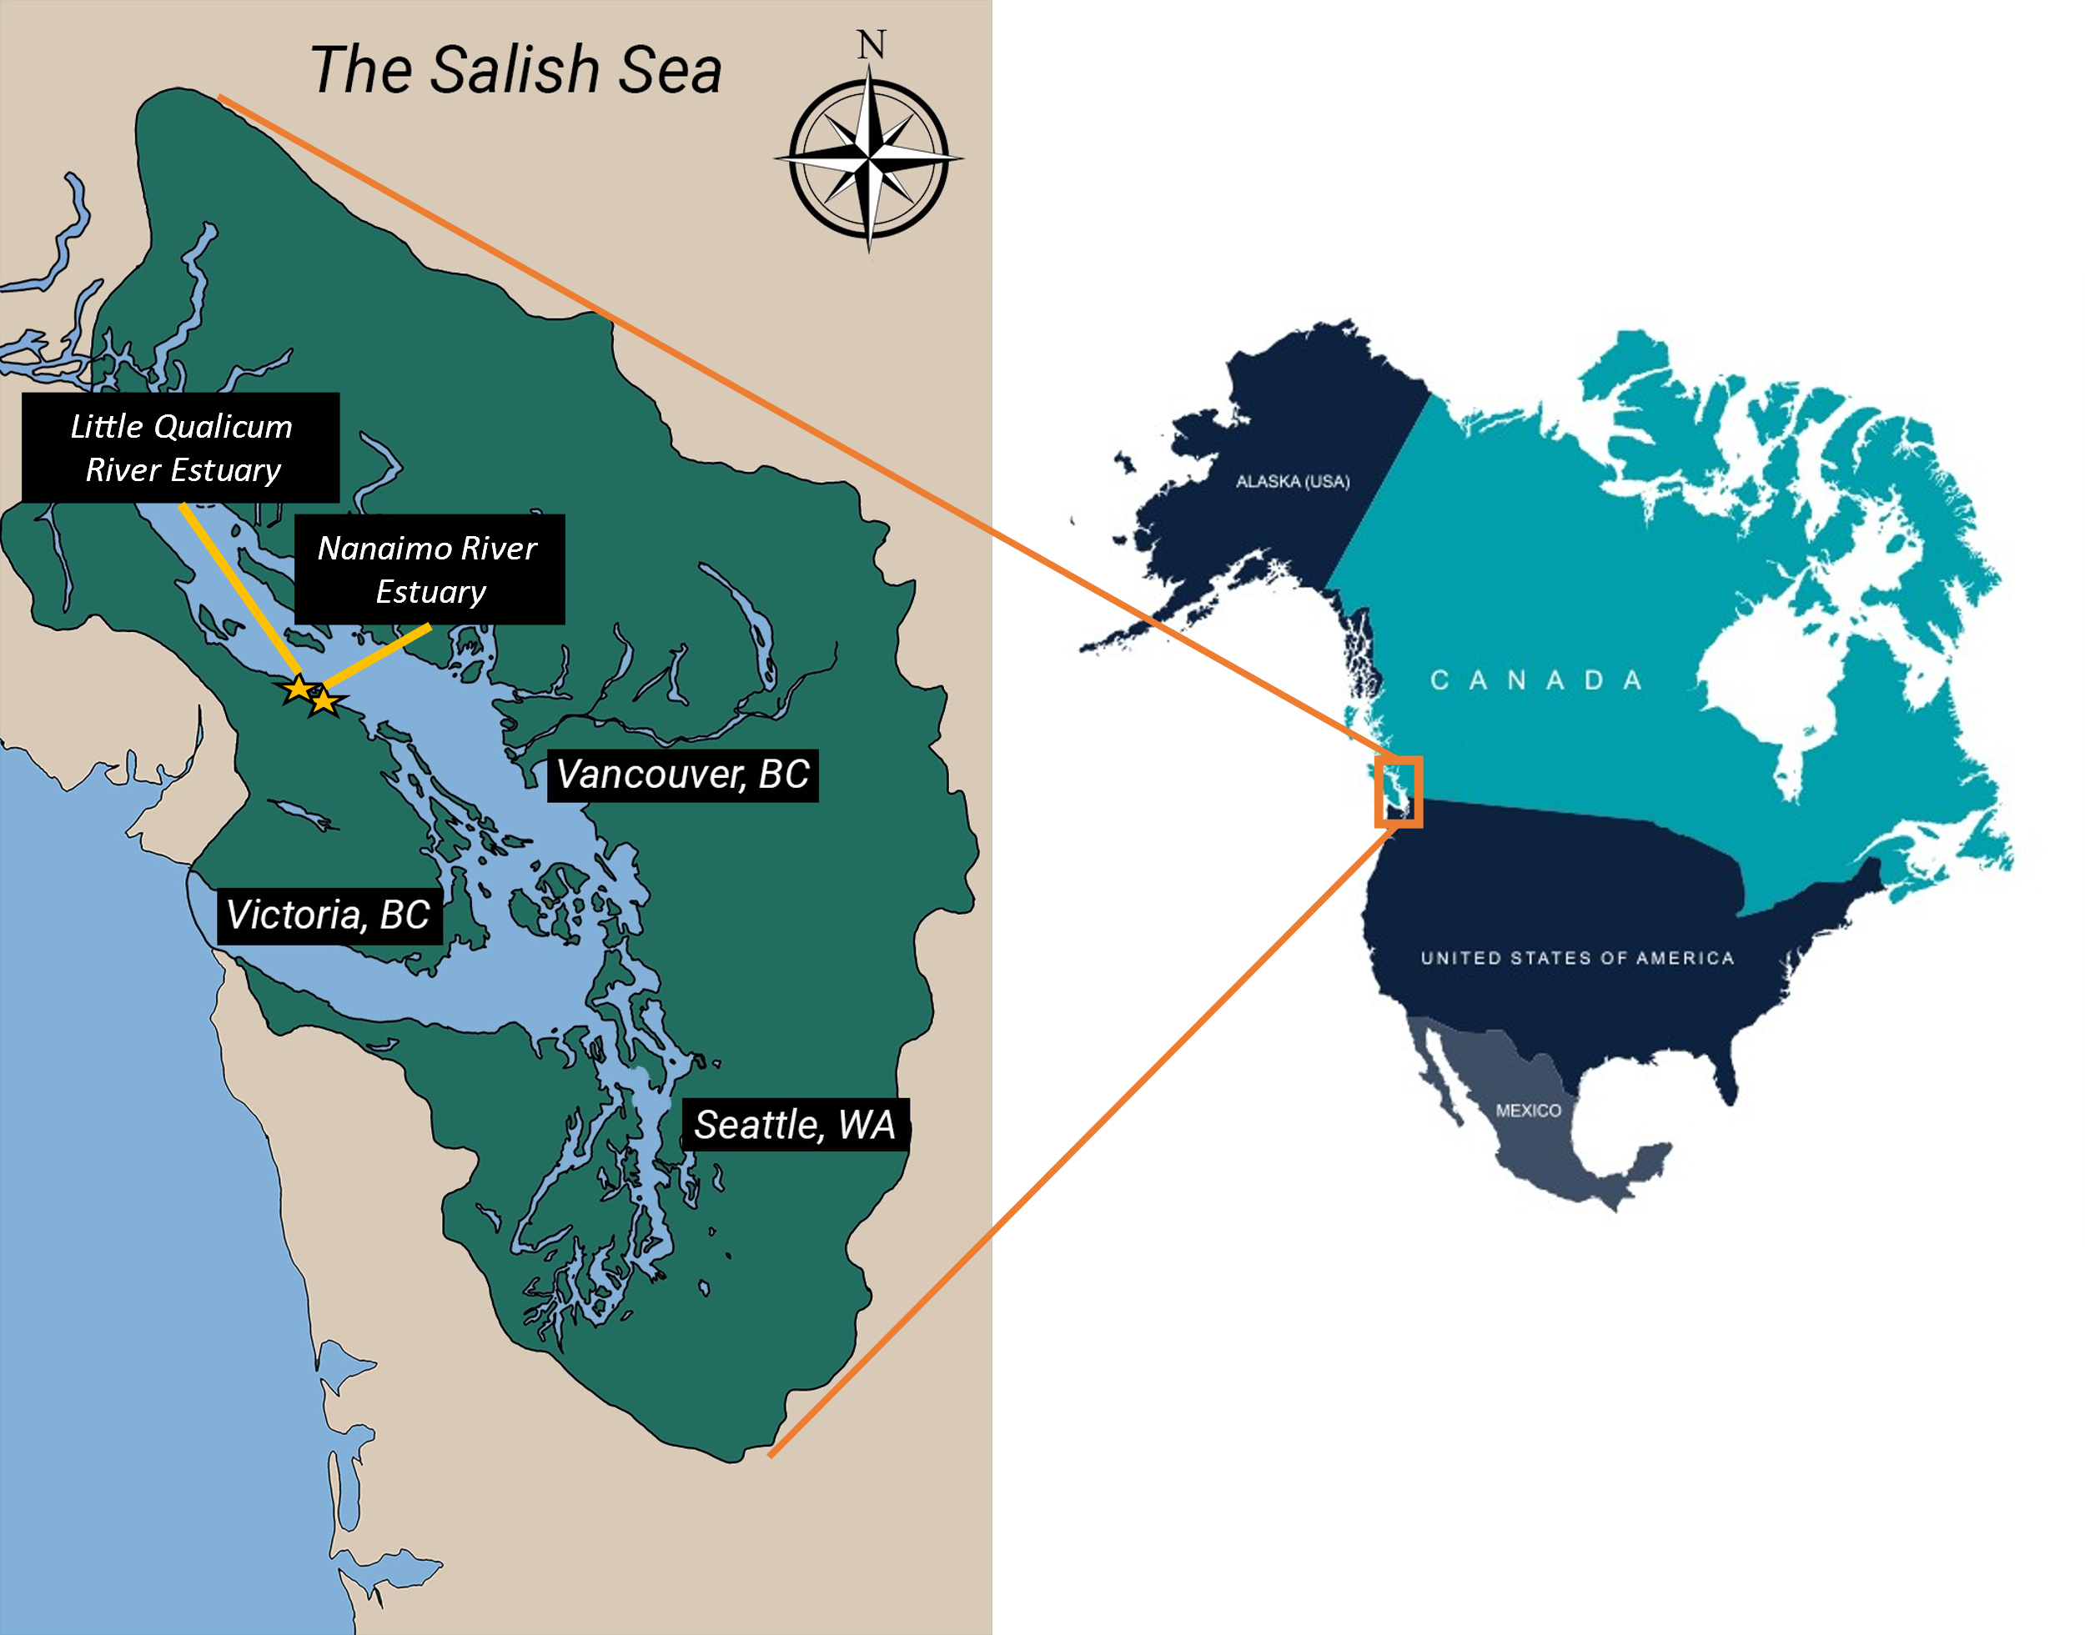

Figure 1. PLACEHOLDER MAP: The Salish Sea spans the US-Canadian border on the Pacific Coast of North America (inset). The Little Qualicum River Estuary and Nanaimo River Estuary are within approx. 40 km of each other along the southeast coast of Vancouver Island. Salish Sea map from IntoTheSalishSea.org, reproduction for publication not permitted.

## **Goose introduction & grazing exclusion**

Canada geese (*Branta canadensis*) were historically a migratory species to Vancouver Island, however in the late 20th century populations were introduced to the island to promote hunting tourism. In the absence of sufficient hunting pressure, these populations have grown hyperabundant and have become resident within the region rather than becoming migratory like their wild counterparts (Dawe & Stewart, 2010). These hyperabundant populations place heavy pressure on estuaries through sustained herbivory, leading to complete loss of above- and below-ground plant structures, denuded marsh platforms, and subsequent sediment and seed bank loss through erosion.

Fences or “exclosures” are commonly used to exclude herbivores, including Canada geese, from continued grazing. A history of exclosure construction since 2010 in the LQRE, and recent history of exclosure construction in NRE since 2020 afford the opportunity to develop a coarse chronosequence of recovery at discrete time periods since grazing disturbance, including Grubbed (denuded mudflat), 1-year old exclosures, 10-year old exclosures, and areas that have no known history of grazing (Undisturbed or “reference”). Exclosures are constructed along the edges of vegetation impacted by grazing activity, with the rationale that remnant vegetation should recover towards a desired Undisturbed or “reference” condition once grazing pressure is relieved.

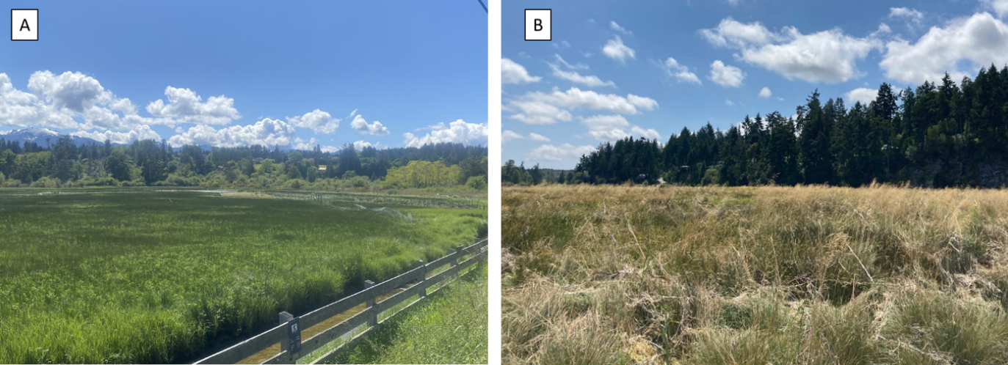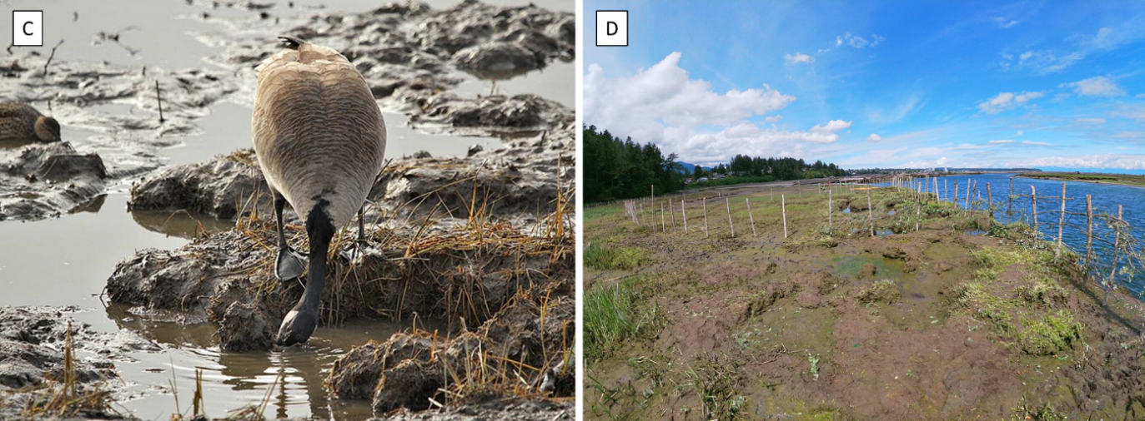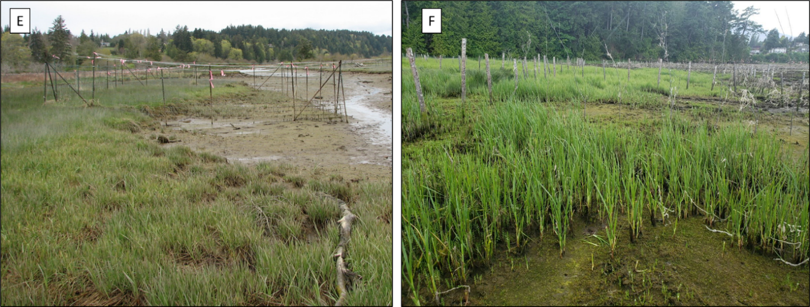

Figure 2. Reference vegetation for this study was defined as areas with no known grazing disturbance and dominated by native species, including Carex lyngbyei in in the Little Qualicum River Estuary (A), and Juncus balticus or Deschampsia caespitosa in the Nanaimo River Estuary (B). Intensive grubbing (C) by Canada geese (Branta canadensis) removes rhizomes and contributes to sediment loss, resulting in large areas of bare or “denuded” mudflat (D). Exclosures were constructed around the edges of these grazed areas to promote vegetation recovery in 2010 in the Little Qualicum River Estuary (E) and Nanaimo River Estuary in 2020 (F). Photo credits (A) Dawson Clermont, 2021, (B) Stefanie Lane, 2021, (C) Gerry Fairbrother, date unknown, (D) Garreth Ashley, 2021, (E) Neil Dawe, 2011, (F) Tim Clermont, 2020

Table 1. Grazing disturbance conditions in the Little Qualicum River and Nanaimo Estuaries resulted in conversion of vegetated marsh to partially or fully grubbed mudflats; exclosures were installed to prevent further degradation into the marsh platform. We sampled n = 4 sites in each estuary, with two 1 m2 vegetation plots per site, and two surface seed bank samples per plot.

|  |  |  |  |  |  |
| --- | --- | --- | --- | --- | --- |
| **Estuary** | **Time Since Disturbance** | **Disturbance condition** | **Protected by exclosure?** | **Total vegetation plots** | **Total surface seed bank samples** |
| Little Qualicum, Nanaimo | 0 years | Actively grubbed | No | 16 | 32 |
| Nanaimo | 1-year post-grazing/grubbing disturbance | Recovering | Yes | 8 | 16 |
| Little Qualicum | 10 years post-grazing/grubbing disturbance | Recovering | Yes | 8 | 16 |
| Little Qualicum, Nanaimo | No known grazing disturbance | Undisturbed | No | 16 | 32 |

## **Sampling methods**

### **Vegetation sampling**

Vegetation sampling was conducted once in mid-July, 2021. Two 1 m2 vegetation plots were placed within the exclosures (sites, n = 4 per disturbance condition in each? estuary), at least 1 m from the bank edge and any exclosure boundary, and at least 3 m apart within the exclosure. Quadrats were placed so that the plot edge nearest creek was parallel to the bank.

All vascular species were identified according Hitchcock and Cronquist (2018). Species were considered in the plot if at least half of their basal stem(s) were inside the quadrat boundary; overhanging vegetation originating from basal stems outside the plot was not considered. Aerial vegetated cover was estimated to the nearest 3 % (1/32 m2). For any species present with less than 3 % cover, species were assigned 2 % cover if > 20 individuals were present, 1 % cover if 2-20 individuals were present, and 0.1% cover for single individuals. Bare ground was estimated as the remainder of the plot area not covered by above-ground vegetation. Any plots with > 100 % cover were standardized relative to 100 % in order to constrain values to fit statistical distributions. To characterize plant structure, all species were assigned to a height category tall (> 1 m), medium (50-100 cm), or short (< 50 cm) based on their maximum reported height in the Illustrated Flora of British Columbia (Douglas et al., 1998). Our key species of interest, tall perennial graminoids (TPGs), were defined as any grass (Poaceae), sedge (Cyperaceae), or rush (Juncaceae) with a biennial or perennial life history and mature height of at least 1 m.

### **Surface seed bank sampling & germination**

Two surface seed bank samples were taken from each plot (n = 16 per disturbance condition in each estuary) in summer (July 2020), fall (October 2020), and spring (March 2021). A 10 cm diameter handheld bulb planter (e.g., [Husky 9 in. stainless Steel Bulb Planter, Home Depot, USA](https://www.homedepot.com/p/Husky-9-in-Stainless-Steel-Bulb-Planter-GD210314/317436441)) was used to excise sediment 1 cm deep to capture the most recent seeds deposited into the marsh sediment, which we call the “surface seed bank.” Vegetative roots, rhizomes, or other viable rooted material were removed before placing sample in a plastic zipper bag. All surface seed bank samples from the same estuary and disturbance condition were then homogenized in a clean bucket with 100 mL dechlorinated water. Samples were hand-sifted for any remaining root, rhizome, or vegetative material, then the homogenized sample was transferred to a clean plastic zipper bag. Summer and fall 2020 samples were stored at 4o C for approx. 12 weeks to simulate overwinter cold stratification to release seed dormancy (Rosbakh et al., 2019); samples collected in the spring of 2021 underwent natural winter conditions within the estuaries and were not subjected to cold stratification.

Germination trials were conducted under greenhouse conditions with 15 hr. daylength at ~ 20o C. Seedling pots (9 cm x 13 cm x 5.7 cm (depth)) were filled with moist, sterile potting media (Sunshine Mix No. 4, Sun Gro Horticulture, Agawam, MA, United States). Pots were placed in solid cache trays and constantly bottom-watered with municipal tap water. Seeds were sown by adding 75 mL of sampled sediments to the top of each seedling pot (n = 8 per estuary and disturbance condition) while constantly agitating the homogenized seed bank sample to prevent seeds from settling to the bottom of the sediment mixture. Seeds were allowed to germinate for 5 weeks, at which time all individuals were counted and removed. The seedling trays were observed for any further germination for another 7-10 days, at which time the samples were discarded. Any species that could not be identified to species at germination were labelled and transplanted into 38 P plug trays with the same growing media and growing conditions until a positive identification could be made.

## Analysis

All analyses were performed in R Studio (v. 4.2.2). Because tall, perennial graminoids (TPGs) are the dominant species group in intact tidal marsh plant communities, we focused most of our analyses on this taxonomic group, however we summarized compositional characteristics for all species. Mean species richness was calculated for all species in the above-ground vegetation and surface seed banks for each disturbance category. For all species, we defined dominance within the above-ground vegetation plots or surface seed bank samples as species having > 25% mean relative abundance. Although a species may be dominant within the vegetation at a site, dominance may not indicate specificity or fidelity to a specific disturbance category. To understand which species could be used to significantly characterize each grazing disturbance condition in the above-ground vegetation and surface seed, we used indicator species analysis (“indicspecies,” R package De Caceres & Jansen, 2016). Species significantly driving compositional abundance in each disturbance category were defined by a biserial correlation coefficient (multipatt func = “r.g.”) and permutational analysis (Dufrene & Legendre, 1997).

Relative abundance in the above ground vegetation was calculated as the proportion of one species relative to the total plot cover, defined as the sum of all vegetation cover and bare ground. Relative abundance in the seed bank sample was calculated as the proportion of one species represented in the total germinants to fit a binomial distribution. To test whether species relative abundance differed among disturbance recovery categories we used separate generalized linear models for the above-ground vegetation and surface seed bank, each with a binomial distribution and logit link function from the R stats package (R Core Team, 2022). Our response variable, the proportion of graminoid abundance in each sample of above-ground vegetation or the surface seed banks, was fit against each disturbance category as the primary predictor, with estuary location as an additional fixed effect to test for geographic differences. We validated the models by predicting means and standard error for proportion of TPGs (‘stats,’ R Core Team, 2022).

# **Results**

## **Above-ground vegetation**

Native species richness was consistently greater than non-native richness across all disturbance categories, although the Little Qualicum River Estuary (LQRE) had the lowest mean native species richness in the Undisturbed and 10-year old exclosures (Figure 3). We found that cover abundance of the dominant group of tall, perennial graminoids (TPGs) was similar to Undisturbed sites after grazing exclusion, however compositional abundance became dominated by non-native, invasive species in the 10-year old exclosure sites (Figure 4). Dominant species were often the same as those identified by indicator species analysis (Table 2) in each disturbance category, although indicator species were not always dominant (Figure 5).

Undisturbed sites in both estuaries (n = 8) were dominated by several TPGs (non-native *Agrostis stolonifera*, and native species *Carex lyngbyei* and *Juncus balticus*), in addition to native broadleaf flowering species *Potentilla pacifica* in LQRE, and *Symphyotrichum subspicatum* in both estuaries (Figure 5). The 10-year old exclosures in LQRE (n = 4) shared similar dominant species, however non-native *A. stolonifera* had greater abundance than native *C. lyngbyei*; native TPG *Juncus balticus* was not dominant, and *S. subspicatum* was not present. Indicator species analysis identified non-native graminoid *A. stolonifera* and native forb *P. pacifica* as significantly characterizing the 10-year old exclosures, while Undisturbed sites included two native graminoids and one forb (*J. balticus*, *C. lyngbyei*, *T. maritima*) (Table 2).

Grubbed sites in both estuaries (n = 8) and 1-year old exclosures in the Nanaimo River Estuary (NRE, n = 4) shared common dominant species, however only the 1-year old exclosures were dominated by a single TPG (*C. lyngbyei*). In Grubbed sites, dominant species in both estuaries included native species *Eleocharis parvula* (very short perennial graminoid, < 10 cm tall) and *Glaux maritima* (short perennial forb, < 30 cm tall), with the additional dominant native species *Spergularia canadensis* (short annual forb, < 30 cm tall) in LQRE (Figure 5). In NRE, 1-year old exclosures were dominated by the same species as in all Grubbed sites (*E. parvula, G. maritima, S. canadensis*), but remnant TPG species *C. lyngbyei* also maintained cover dominance in above-ground vegetation (Figure 5).

Indicator species analysis identified *S. canadensis* and *G. maritima* as species significantly characterizing 1-year old exclosures, while native, short graminoid *E. parvula* and non-native forb *Cotula coronopifolia* (short (< 30 cm) perennial forb) significantly characterized just the Grubbed sites (Table 2). Generalized linear models showed Grubbed sites had significantly lower TPG above-ground cover as compared to Undisturbed sites (p = 0.02), however 1-year old exclosures in NRE did not have significantly lower TPG cover than Undisturbed sites (p = 0.09) (Figure 6).

## **Surface seed banks and comparison to above-ground vegetation**

As with above-ground vegetation, native species richness was greater than non-native richness, and mean species richness was comparable between all disturbance categories (Figure 3). Relative abundance of TPG seeds was greater in the 10-year old exclosures at LQRE than in Undisturbed sites at both estuaries, however seed of any TPG species was nearly absent from Grubbed sites in both estuaries, and 1-year old exclosures at NRE (Figure 4). Additionally, we found surface seed banks had fewer dominant species in each of the disturbance categories than above-ground vegetation (Figure 5).

Dominant surface seed bank species in Undisturbed sites varied by estuary, with no TPG species dominating in NRE. In LQRE, both the Undisturbed and 10-year old exclosures were dominated by the same two species (non-native *A. stolonifera* and native *J. balticus*) (Figure 5). Indicator species for the surface seed bank in 10-year old exclosures in LQRE included non-native *A. stolonifera*, native *J. balticus*, and native *T. maritima.* Indicators of Undisturbed surface seed banks in both estuaries included native TPGs *C. lyngbyei* and *Juncus articulatus*, as well as non-native forb *C. coronopifolia* (Table 2). This was contrasted by no dominant or indicator species in the surface seed banks of 1-year old exclosures, and the only indicator of Grubbed sites was native forb *Salicornia depressa*. Grubbed sites in both estuaries were dominated by native, short graminoid *E. parvula*, while native forb *S. canadensis* was dominant only in seed bank samples from Grubbed sites at LQRE. No species were seed-dominant in 1-year old exclosures in NRE. Our generalized linear models showed Nanaimo River Estuary had significantly lower TPG seed abundance overall (p = 0.02), and Grubbed sites had significantly lower TPG seed abundance, regardless of estuary (p = 0.05) (Figure 6).

We found surface seed bank compositional abundance differed from vegetation at Grubbed sites, as many of the species found in the above-ground vegetation were not present in the surface seed bank (Figure 5). In 10-year old exclosures, native *C. lyngbyei* recovered as dominant vegetation, but abundance of its seed in the surface seed bank was much lower than that in Undisturbed sites. This was contrasted by non-native invasive *A. stolonifera*, whose seed dominated surface seed banks in 10-year old exclosures and Undisturbed sites, and its dominance in above-ground vegetation was greater at 10-year old sites than in Undisturbed sites. Though the native forb *Symphyotrichum subspicatum* was dominant in vegetation at Undisturbed sites, it was absent from the vegetation and surface seed bank in 10-year old exclosures.

Table 2. Indicator species analysis identified which species significantly characterize the above-ground vegetation (left panel) and surface seed bank (right panel) for each disturbance condition of “recently disturbed” (1-year old exclosures and Grubbed sites) and “recovered” (10-year old exclosures), and Undisturbed sites. Non-native species are indicated by asterisk (*); tall perennial graminoids indicated by plus sign (+).

|  |  |  |  |  |  |  |
| --- | --- | --- | --- | --- | --- | --- |
| Above Ground Vegetation | | |  | Below Ground Seed Bank | | |
| **Disturbance** | **Species** | **p-value** |  | **Disturbance** | **Species** | **p-value** |
| Undisturbed | *Juncus balticus* | 0.02 |  | Undisturbed | *Carex lyngbyei* | 0.02 |
| *Carex lyngbyei* | 0.02 |  | *Cotula coronopifolia\** | 0.03 |
| *Triglochin maritima* | 0.04 |  | *Juncus articulatus* | 0.04 |
| 10-year old exclosures | *Agrostis stolonifera\** | < 0.01 |  | 10-year old exclosures | *Juncus balticus* | < 0.01 |
| *Potentilla pacifica* | 0.04 |  | *Agrostis stolonifera\** | < 0.01 |
|  |  |  | *Triglochin maritima* | 0.04 |
| 1-year old exclosures | *Spergularia canadensis* | < 0.01 |  | 1-year old exclosures |  |  |
| *Glaux maritima* | 0.03 |  |  |  |
| Grubbed | *Eleocharis parvula* | < 0.01 |  | Grubbed | *Salicornia depressa* | 0.02 |
| *Cotula coronopifolia\** | 0.04 |  |  |  |

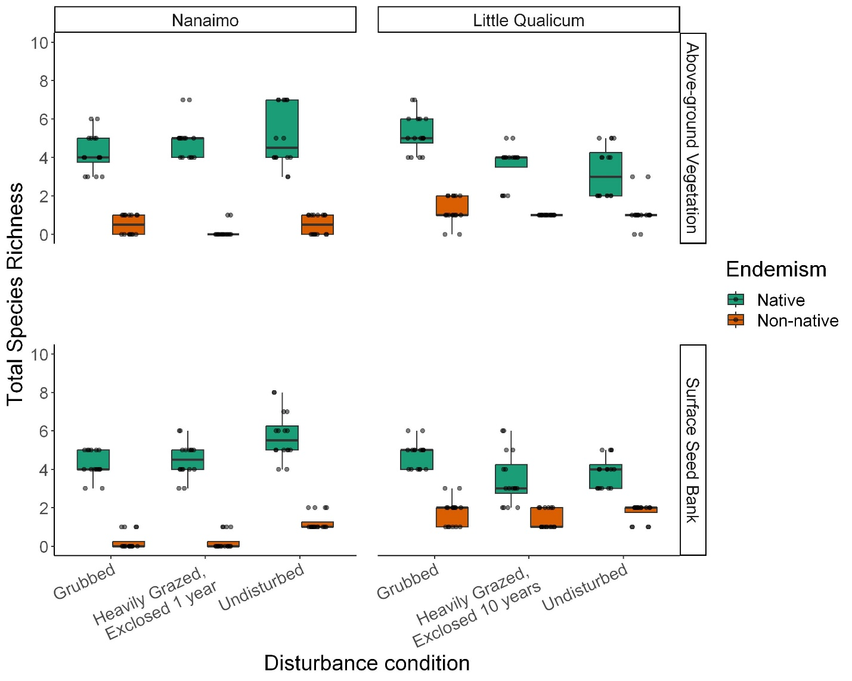

Figure 3. Species richness of native vs. non-native plants was even among disturbance categories in both Nanaimo and Little Qualicum River Estuaries for both above-ground vegetation and surface seed banks.

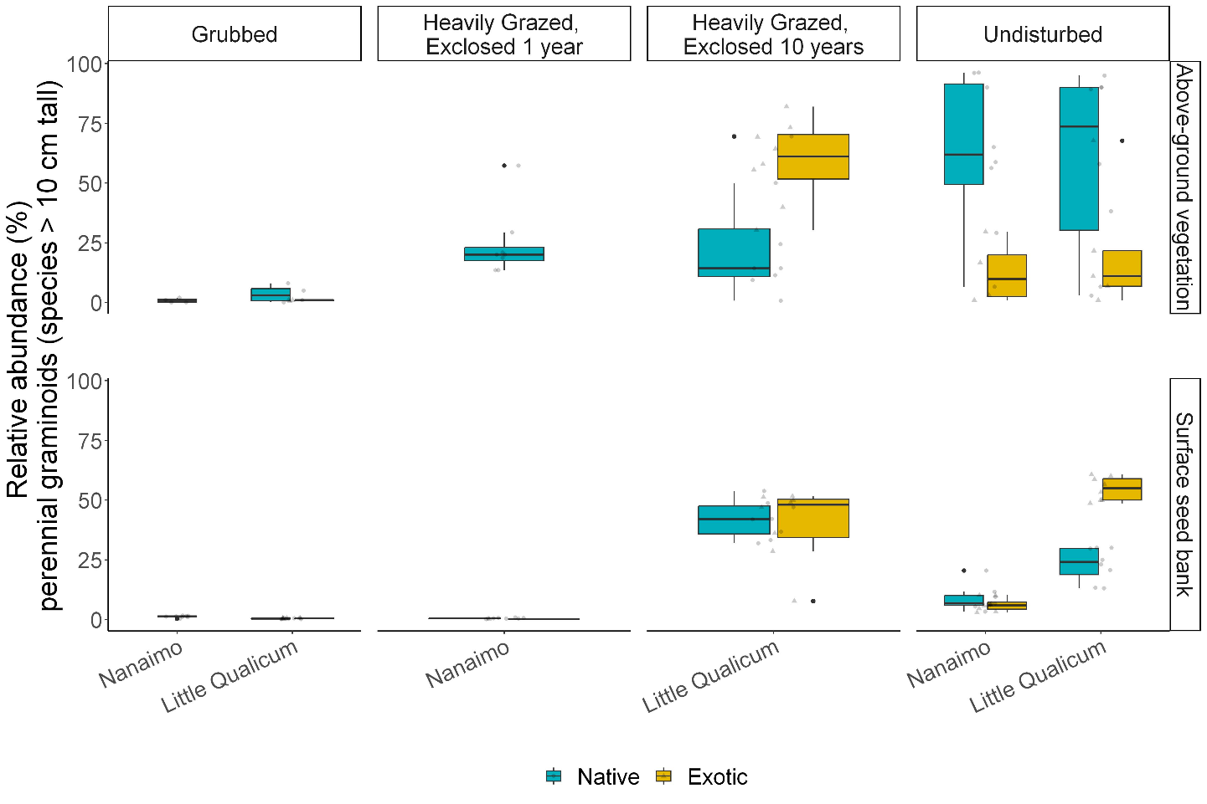

Figure 4. Above-ground cover abundance of key functional group ‘tall, perennial graminoids’ is not significantly different from undisturbed (reference) sites after 10 years. However, indicator species analysis reveals this above-ground cover is dominated by non-native graminoid species Agrostis stolonifera. Moreover, seed bank abundance of tall, perennial graminoids is significantly higher in 10-year old exclosures compared to other disturbance conditions, including undisturbed (reference) sites. Notably, there is a nearly equal abundance of non-native and native graminoid seed in 10-year old exclosures, and significantly greater representation of non-native than native graminoid seed in Undisturbed sites in Little Qualicum Estuary.

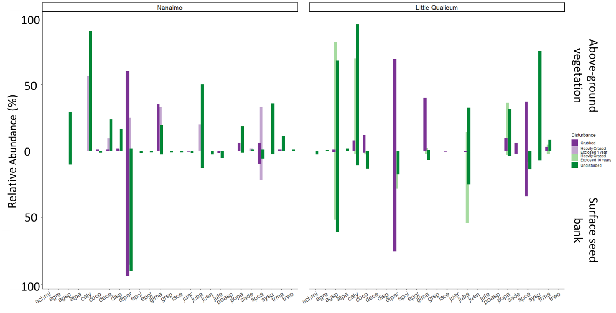

Figure 5. Mean relative abundance of all species in above-ground vegetation and surface seed bank at each estuary sampled. Notably, abundance of key native TPGs such as Carex lyngbyei are absent from the seed bank, while others such as Juncus balticus are dominant (> 25% relative abundance) in the seed bank but not dominant in above-ground vegetation, such as observed in 10-year old exclosures at Little Qualicum Estuary.

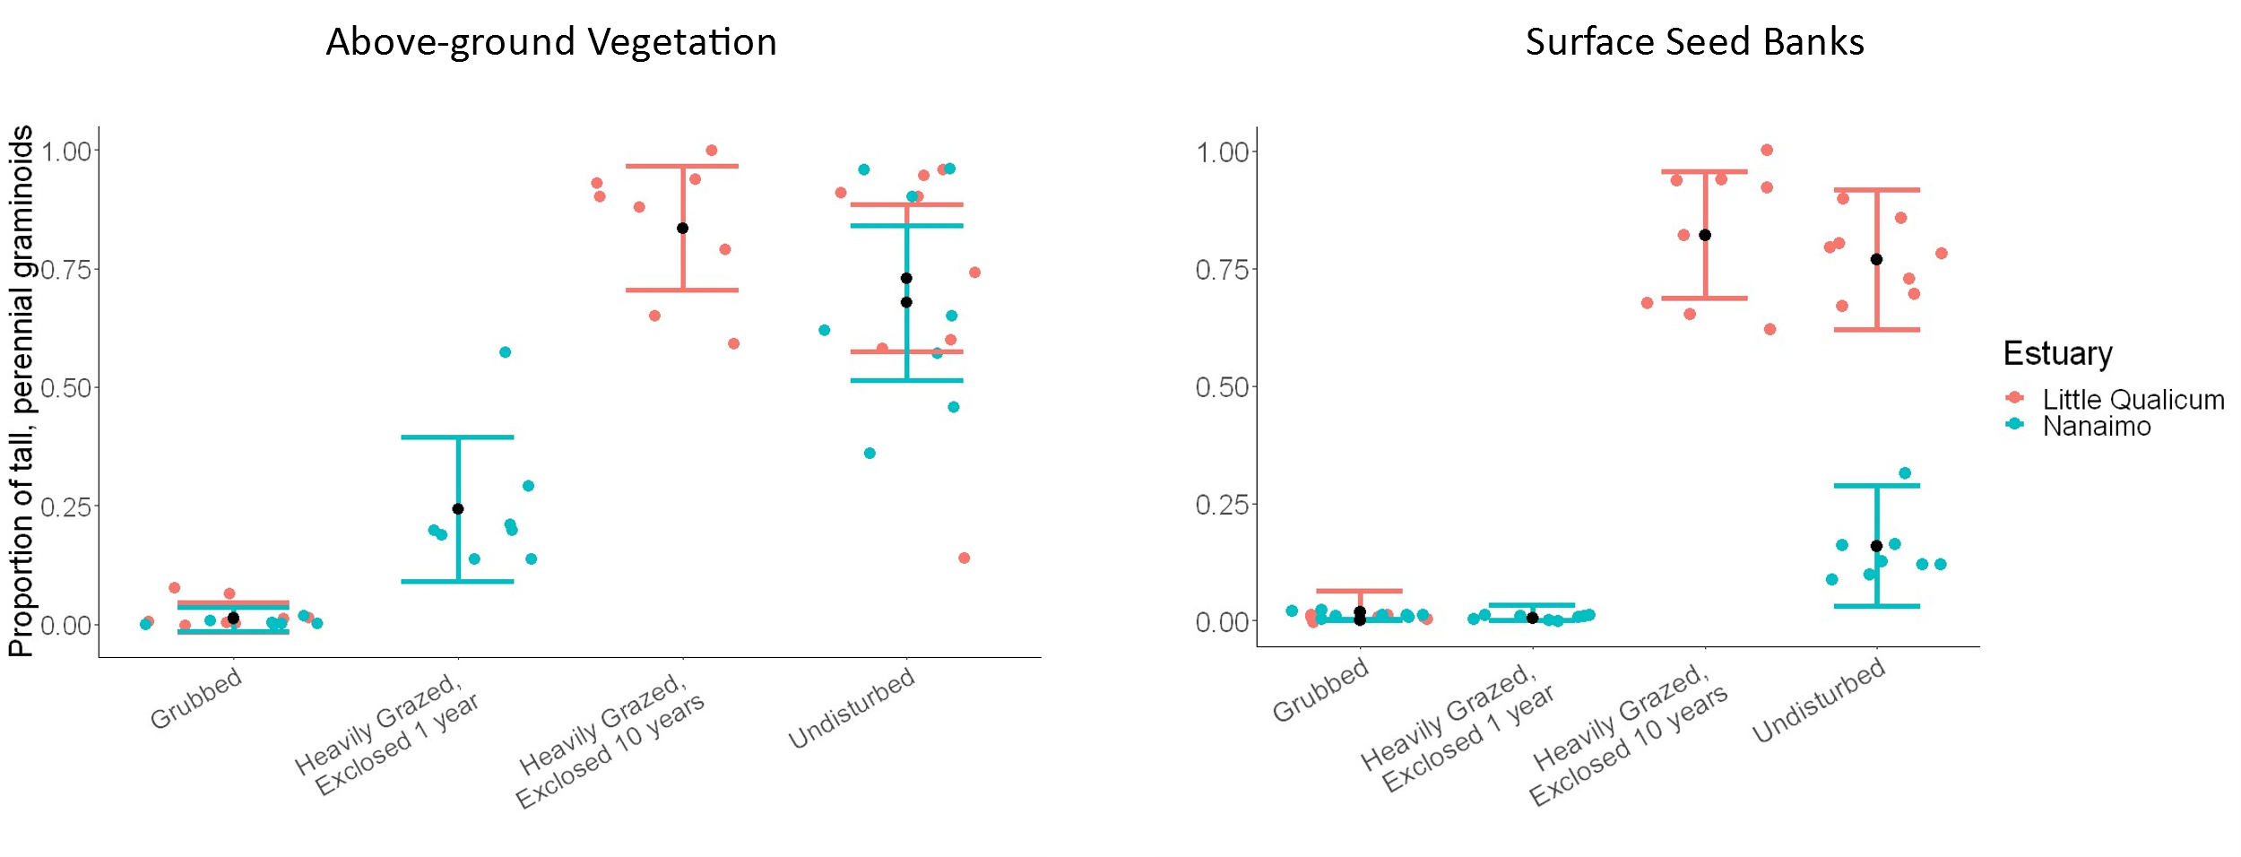

Figure 6. Actual vs. predicted values for proportion of tall, perennial graminoid in above-ground vegetation cover (left) and surface seed bank samples (right) based on disturbance condition. Actual values plotted as colored points for Little Qualicum River Estuary (salmon pink) and Nanaimo River Estuary (turquoise); estimated mean values black points with standard error color coded for each estuary.

# **Discussion**

We wanted to understand whether the competitively dominant tall, perennial graminoids (TPGs) recovered following grazing disturbance, and whether recovery of surface seed banks resembled above-ground vegetation composition. We found that after 10 years of grazing exclusion, the dominant plant group of tall, perennial graminoids (TPGs) recovered in the above-ground vegetation according to our expectations, however non-native species *Agrostis stolonifera* had become the dominant species in both the vegetation and surface seed banks. Additionally, we found significantly lower relative abundance of TPGs in the above-ground vegetation and surface seed bank in the Grubbed sites at both estuaries, and significantly lower relative abundance of TPG species in the surface seed banks at 1-year old exclosures at Nanaimo River Estuary (NRE) (Figure 6). Given that non-native species dominate the recovered vegetation and surface seed banks after 10 years of grazing exclusion at Little Qualicum River Estuary (LQRE), we suggest that these disturbed habitats are recovering towards an alternative compositional state.

Non-native TPGs may have a greater competitive recruitment advantage, contributing to this alternative recovery trajectory following disturbance by grubbing. This may be driven at least in part by high seed production, resulting in a “weighted lottery” (Lavorel & Lebreton, 1992) of seed propagules from which the plant community can recover. In addition, it is likely that these species are also characterized by more competitive recruitment strategies than native TPGs. For example, the two TPG species with greatest representation in surface seed banks in Undisturbed at both estuaries and 10-year old exclosures in LQRE were native *J. balticus* and non-native, invasive *A. stolonifera* (Figure 5). Despite these two species having similar seed propagule loads, native *J. balticus* is not dominant in the above-ground vegetation, suggesting that its seed and clonal recruitment strategies were not sufficient to out-compete those of *A. stolonifera*. If these two species had comparable competitive recruitment traits, we might expect a similar proportion of cover abundance in the above ground vegetation in 10-year old exclosures (Aicher et al., 2011). Additionally, seed limitation of some species like *Carex lyngbyei* result in reliance on recovery from clonal reproduction which may be insufficient to out-compete non-native, invasive species like *A. stolonifera* (Kettenring & Galatowitsch, 2011).

This could imply that even when ecological memory remains through clonal fragments, it may be overwhelmed by the novel propagule pressures from the surrounding landscape. This post-disturbance recovery dominated by novel species may also exacerbate disturbance-driven losses of ecological memory, and hinder efforts to passive restore native composition (Johnstone et al., 2016). However, such intensely altered propagule loads were site-specific. Non-native species *A. stolonifera* was not dominant in the surface seed banks in Undisturbed sites in NRE. We also noted *A. stolonifera* did not appear in the surface seed banks of 1-year old exclosures in this estuary. It is notable that indicator species analysis did identify any species as significantly characterizing 1-year old exclosures at NRE (Table 2). This suggests that overgrazing and grubbing removes not only vegetative growth but contributes to the loss of propagules in the surface seed bank via erosion when vegetation is stripped away. Importantly, invasive species like *A. stolonifera* had not been deposited and retained within the first year after disturbance was removed.

Some native, clonally reproductive species did not appear to recover following disturbance. For example, *S. subspicatum* was dominant in the above-ground vegetation and present in surface seed banks at Undisturbed sites in both estuaries, but neither plants nor seed were found in any other disturbance categories, including the 10-year old exclosures at LQRE (Figure 5). This may indicate that there are critical windows of opportunity in which native species propagule loads must recover (Fivash et al., 2021). If they are unlikely to disperse from the surrounding landscape, land managers may need to actively intervene through seed and plant addition to preserve their presence in the landscape. As with many restoration projects in degraded lands, this will likely need to be coupled with suppression of competitive non-native species invasion to offset the disproportionate representation of those species in the arriving propagule pool.

Successful passive restoration methods are dependent on the extent and duration of the disturbance (Meli et al., 2017), and may be inappropriate in ecosystems with a history of invasive species (Shackelford et al., 2019). If propagules of non-native, invasive species are competitively successful within the available windows of opportunity to the point of excluding native species richness and abundance, then passive restoration methods such as grazing exclosures are insufficient to restore to habitat conditions comparable to the pre-disturbance state. We suggest that in these estuaries, passive recovery creates a temporal window of opportunity in which non-native invasive species like *A. stolonifera* can gain dominance, and therefore active restoration is required for native communities to recover. Because the cumulative impacts of overgrazing and high propagule loads of non-native species may reset the recovery trajectory with unknown consequences for ecosystem function (Mack et al., 2000), we recommend actively transplanting a diversity of native species as soon as possible following removal of grazing disturbance to expedite habitat recovery.

We especially want to emphasize that the sites sampled at Little Qualicum River Estuary appears to have a greater threat of non-native invasive species encroachment than sites sampled at Nanaimo River Estuary (Figure 4), despite its status as a protected Wildlife Management Area since 1993, and reiterate calls for active management in Pacific Northwest estuaries (see also Stewart et al., 2023, Lane et al., in review). We propose that these management urgencies are timely in the conversation around ecological stewardship and reconciliation with First Nations, as grazing disturbance presents a “blank slate” for restoration of historic and culturally appropriate native species. This offers a chance to enact reconciliation partnerships with local First Nations to use culturally important species, and potentially restore traditional land management practices such as estuary root gardens (e.g., Turner, 2014). However, we caution that restoration of cultural practices must necessarily be led and managed by each Nation (CITE), and that if time and resources cannot guarantee autonomous leadership to restore cultural practices by Indigenous members, we suggest restoration protocols should prioritize selection of culturally important species to achieve the ecological goal of restoring propagule loads while minimizing invasive species dominance within the estuary habitat.

# Literature Cited

Abernethy, V. J., & Willby, N. J. (1999). Changes along a disturbance gradient in the density and composition of propagule banks in floodplain aquatic habitats. *Plant Ecology*, *140*(2), 177–190. https://doi.org/10.1023/A:1009779411686

Aicher, R. J., Larios, L., & Suding, K. N. (2011). Seed Supply, Recruitment, and Assembly: Quantifying Relative Seed and Establishment Limitation in a Plant Community Context. *The American Naturalist*, *178*(4), 464–477. https://doi.org/10.1086/661900

Balke, T., Herman, P. M. J., & Bouma, T. J. (2014). Critical transitions in disturbance-driven ecosystems: Identifying Windows of Opportunity for recovery. *Journal of Ecology*, *102*(3), 700–708. https://doi.org/10.1111/1365-2745.12241

Bertness, M. D. (1991). Interspecific Interactions among High Marsh Perennials in a New England Salt Marsh. *Ecology*, *72*(1), 125–137. JSTOR. https://doi.org/10.2307/1938908

Borde, A. B., Diefenderfer, H. L., Cullinan, V. I., Zimmerman, S. A., & Thom, R. M. (2020). Ecohydrology of wetland plant communities along an estuarine to tidal river gradient. *Ecosphere*, *11*(9), e03185. https://doi.org/10.1002/ecs2.3185

Bruno, J. F. (2000). Facilitation of Cobble Beach Plant Communities Through Habitat Modification by Spartina Alterniflora. *Ecology*, *81*(5), 1179–1192. https://doi.org/10.1890/0012-9658(2000)081[1179:FOCBPC]2.0.CO;2

Clermont, H. (2010). *Little Qualicum River Estuary Regional Conservation Area Guardian of the Estuary 2010-2019 Management Plan*. Regional District of Nanaimo. https://www.rdn.bc.ca/cms/wpattachments/wpID2040atID3337.pdf

Dawe, N., Boyd, S., Buechert, R., & Stewart, A. (2011). Recent, significant changes to the native marsh vegetation of the Little Qualicum River estuary, British Columbia; a case of too many Canada Geese (Branta canadensis)? *Journal of the British Columbia Field Ornithologists*, *21*, 11–31.

Dawe, N. K., & Stewart, A. C. (2010). The Canada Goose (Branta canadensis) on Vancouver Island, British Columbia. *British Columbia Birds*, *20*, 18.

Diefenderfer, H. L., Steyer, G. D., Harwell, M. C., LoSchiavo, A. J., Neckles, H. A., Burdick, D. M., Johnson, G. E., Buenau, K. E., Trujillo, E., Callaway, J. C., Thom, R. M., Ganju, N. K., & Twilley, R. R. (2021). Applying cumulative effects to strategically advance large-scale ecosystem restoration. *Frontiers in Ecology and the Environment*, *19*(2), 108–117. https://doi.org/10.1002/fee.2274

Douglas, G. W., Meidinger, D., & Pojar, J. (Eds.). (1998). *Illustrated flora of British Columbia. Vols. 1-8*. B.C. Min. Environ., Lands and Parks, and B.C. Min. For. https://www.cabdirect.org/cabdirect/abstract/20013088729

Finn, R. J. R., Chalifour, L., Gergel, S. E., Hinch, S. G., Scott, D. C., & Martin, T. G. (2021). Quantifying lost and inaccessible habitat for Pacific salmon in Canada’s Lower Fraser River. *Ecosphere*, *12*(7), e03646. https://doi.org/10.1002/ecs2.3646

Fivash, G. S., Temmink, R. J. M., D’Angelo, M., van Dalen, J., Lengkeek, W., Didderen, K., Ballio, F., van der Heide, T., & Bouma, T. J. (2021). Restoration of biogeomorphic systems by creating windows of opportunity to support natural establishment processes. *Ecological Applications*, *31*(5), e02333. https://doi.org/10.1002/eap.2333

Hitchcock, C. L., & Cronquist, A. (2018). *Flora of the Pacific Northwest, an illustrated manual* (D. E. Giblin, B. S. Legler, P. F. Zika, & R. G. Olmstead, Eds.; 2nd ed.). University of Washington Press.

Johnstone, J. F., Allen, C. D., Franklin, J. F., Frelich, L. E., Harvey, B. J., Higuera, P. E., Mack, M. C., Meentemeyer, R. K., Metz, M. R., Perry, G. L., Schoennagel, T., & Turner, M. G. (2016). Changing disturbance regimes, ecological memory, and forest resilience. *Frontiers in Ecology and the Environment*, *14*(7), 369–378. https://doi.org/10.1002/fee.1311

Kettenring, K. M., & Galatowitsch, S. M. (2011). Seed Rain of Restored and Natural Prairie Wetlands. *Wetlands*, *31*(2), 283–294. https://doi.org/10.1007/s13157-011-0159-6

Lavorel, S., & Lebreton, J. D. (1992). Evidence for lottery recruitment in Mediterranean old fields. *Journal of Vegetation Science*, *3*(1), 91–100. https://doi.org/10.2307/3236002

Mack, R. N., Simberloff, D., Mark Lonsdale, W., Evans, H., Clout, M., & Bazzaz, F. A. (2000). Biotic Invasions: Causes, Epidemiology, Global Consequences, and Control. *Ecological Applications*, *10*(3), 689–710. https://doi.org/10.1890/1051-0761(2000)010[0689:BICEGC]2.0.CO;2

Meli, P., Holl, K. D., Benayas, J. M. R., Jones, H. P., Jones, P. C., Montoya, D., & Mateos, D. M. (2017). A global review of past land use, climate, and active vs. Passive restoration effects on forest recovery. *PLOS ONE*, *12*(2), e0171368. https://doi.org/10.1371/journal.pone.0171368

Pasternack, G. B. (2009). Chapter 3. Hydrogeomorphology and sedimentation in tidal freshwater wetlands. In A. Barendregt, D. F. Whigham, & A. H. Baldwin (Eds.), *Tidal Freshwater Wetlands* (pp. 31–40). Backhuys Publishers.

Price, E. P. F., Spyreas, G., & Matthews, J. W. (2020). Biotic homogenization of wetland vegetation in the conterminous United States driven by Phalaris arundinacea and anthropogenic disturbance. *Landscape Ecology*, *35*(3), 779–792. https://doi.org/10.1007/s10980-020-00978-x

Rosbakh, S., Hülsmann, L., Weinberger, I., Bleicher, M., & Poschlod, P. (2019). Bleaching and cold stratification can break dormancy and improve seed germination in Cyperaceae. *Aquatic Botany*, *158*, 103128. https://doi.org/10.1016/j.aquabot.2019.103128

Schaefer, V. H. (2011). Remembering our roots: A possible connection between loss of ecological memory, alien invasions and ecological restoration. *Urban Ecosystems*, *14*(1), 35–44. https://doi.org/10.1007/s11252-010-0138-3

Shackelford, N., Murray, S. M., Bennett, J. R., Lilley, P. L., Starzomski, B. M., & Standish, R. J. (2019). Ten years of pulling: Ecosystem recovery after long-term weed management in Garry oak savanna. *Conservation Science and Practice*, *1*(10), e92. https://doi.org/10.1111/csp2.92

Silinski, A., van Belzen, J., Fransen, E., Bouma, T. J., Troch, P., Meire, P., & Temmerman, S. (2016). Quantifying critical conditions for seaward expansion of tidal marshes: A transplantation experiment. *Estuarine, Coastal and Shelf Science*, *169*, 227–237. https://doi.org/10.1016/j.ecss.2015.12.012

Simberloff, D., Martin, J.-L., Genovesi, P., Maris, V., Wardle, D. A., Aronson, J., Courchamp, F., Galil, B., García-Berthou, E., Pascal, M., Pyšek, P., Sousa, R., Tabacchi, E., & Vilà, M. (2013). Impacts of biological invasions: What’s what and the way forward. *Trends in Ecology & Evolution*, *28*(1), 58–66. https://doi.org/10.1016/j.tree.2012.07.013

Srivastava, D. S., & Jefferies, R. L. (1996). A Positive Feedback: Herbivory, Plant Growth, Salinity, and the Desertification of an Arctic Salt-Marsh. *Journal of Ecology*, *84*(1), 31–42. JSTOR. https://doi.org/10.2307/2261697

Stewart, D., Hood, W. G., & Martin, T. G. (2023). Undetected but Widespread: The Cryptic Invasion of Non-Native Cattail (Typha) in a Pacific Northwest Estuary. *Estuaries and Coasts*. https://doi.org/10.1007/s12237-023-01171-4

Tilman, D. (1990). Constraints and Tradeoffs: Toward a Predictive Theory of Competition and Succession. *Oikos*, *58*(1), 3–15. JSTOR. https://doi.org/10.2307/3565355

Turner, N. J., Lepofsky, D., & Deur, D. (2013). Plant Management Systems of British Columbia’s First Peoples. *BC Studies: The British Columbian Quarterly*, *179*, Article 179. https://doi.org/10.14288/bcs.v0i179.184112